(Approx. 827 words)

Tom’s Tech-Notes
Customizing Your Android Home Screen
By Tom Burt, Editor, Sun City Summerlin Computer Club, NV
July 2018 issue, The Gigabytes Gazette
www.scscc.club/
tomburt89134 (at) cox.net

Overview
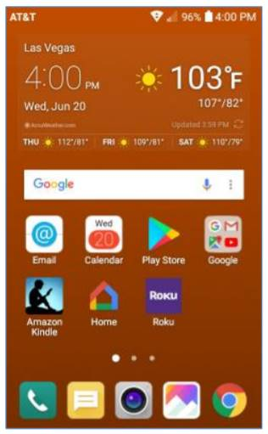
I was recently working on the handouts for my “Android for Beginners” seminar and making quite a few screen shots on my Android Phone. As I got to the material about Display Settings, I got to thinking about what options were available to customize my Home Screen.

I had been using the LG default home screen background, which was a busy set of gray and black triangles, reminiscent of a backgammon board pattern. I went looking for a setting that would let me just have a plain color as my background. There was no such option on my LG Phoenix 3 with Android 7 (Nougat). What to do?

There WAS an option to use a picture/image of my choosing. So, I said to myself “Self? Can you make an image of a plain background color, or even better, a gradient that fades subtly from light to dark?” A milli-second or two later, I had determined exactly how to proceed.

I’ll detail those steps for you in the following, along with a few other Home Screen settings that you might want to try. The screen shot at left shows the results.

Disclaimer: The screen shots and steps given here are for a LG Phoenix 3 running Android 7 (Nougat) with AT&T as my carrier. Your own Android phone may be slightly to wildly different.

Making the Background Image My favorite Windows tool for creating and editing images is the free Paint.Net. Among its palette of tools is a gradient tool that lets you create a canvas that lets you create a smooth fade from one color to another. I started Paint.net with a new, empty canvas. I set the canvas size to 480 wide by 792 tall, which is the size in pixels of my 5-inch LG Phoenix 3 phone’s screen. Your phone’s screen metrics may be different.

Next, I went to the Paint.Net color mixer and selected, for my primary color, a medium copper. I then selected, for my secondary color, a dark copper. You can select any two colors, but the more different they are, the more banded your gradient will look.

Next, I selected the gradient tool and, on the toolbar, chose “linear”. I positioned my cursor at the top of the canvas in the exact center and then dragged down to the bottom of the canvas. The canvas filled with the medium copper to dark copper gradient. I then saved the canvas (image) as TomWallPaperCopper.jpg.

Moving the Image to the Android Cell Phone I used a USB cable to connect my cell phone to my Windows PC. The phone must be powered on and you will likely have to use the swipe down settings menu to change the USB connection from charging to MTP (data) mode. On your Windows PC, the phone will appear in “This PC” as a new attached device. You can then use Windows file management functions to copy files to / from your Android device. I copied my new gradient image (TomWallPaperCopper.jpg) to the DCIM\Camera folder on my LG smart phone. This folder is part of the Android Gallery.

Setting the new image as the Wallpaper for the Home Screen I returned to the smart phone and selected Settings>Display>Home screen>Wallpaper. I then tapped Gallery as my source. Within the Gallery, I navigated to and tapped the image of the copper gradient.
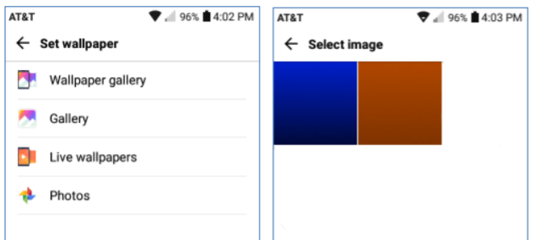

I then tapped OK and finally, on the confirm prompt, tapped Set. I did not check the checkbox to use the same image as my lock screen background. This made my copper gradient image the background for the home screen. Note in the screen shot above that I had also made a medium blue to black gradient. I used that image as the background for my phone’s lock screen.

You can create any number of similar background images or use favorite pictures (properly cropped and sized) as backgrounds. Let your imagination go wild.

Choosing Your Home Screen Style
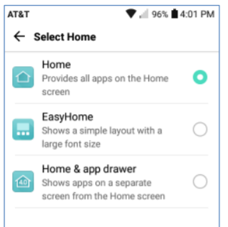
Select Settings>Display>Home screen>Select Home and you will have a choice of three basic Home Screen styles. The default is Home.

If you don’t like endless swiping to find App icons, you may want to try EasyHome or Home & app drawer as alternatives.

The App Drawer is an icon that, when tapped, shows all the App icons on a separate screen.

Summary Your Android Home Screen, much like your Windows Desktop, is a place you spend a lot of time on when using your smart phone. It’s worth taking a little time to get it set up in a way that makes it easy and comfortable for you to use.

There are many other settings you may choose to tweak. If, during experimenting, you get off into the weeds, you can always go back and revert to the original factory defaults.

Have fun



